EOL COMPATIBILITY VIEW SETTINGS (rev. 01/15/2015)

If you are getting a blue screen like below or the blue screen with a series of Employee Online repeated on the left side of the page, then you have to set your compatibility view setting in IE.
First, we need to get the Menu bar for the TOOLS selection.

Try this easy method first for steps 1 - 3. Continue to use steps 4 – 9 to complete the process.

- If the caller does not have the toolbar showing with the TOOLS option on it, tell them to press their ALT key one time.
- The toolbar will appear and the TOOLS option will be available for us to direct them through the settings.
- Proceed to steps 4 – 9 below to complete the process.
When finished, just press the ALT key again to remove the toolbars if it is still visible after you have done steps 4 – 9.
===============================================================================================
If the above method is not working for you, then use these detailed steps for 1 -3 below and proceed with 4 – 9.
- Move your mouse to a blank area at the top of your window (see arrow example below).
- Right Click your mouse button to get the selection dropdown (see example 2)

- Left click in the box in front of Menu Bar, to select it. A menu will appear. See next example.
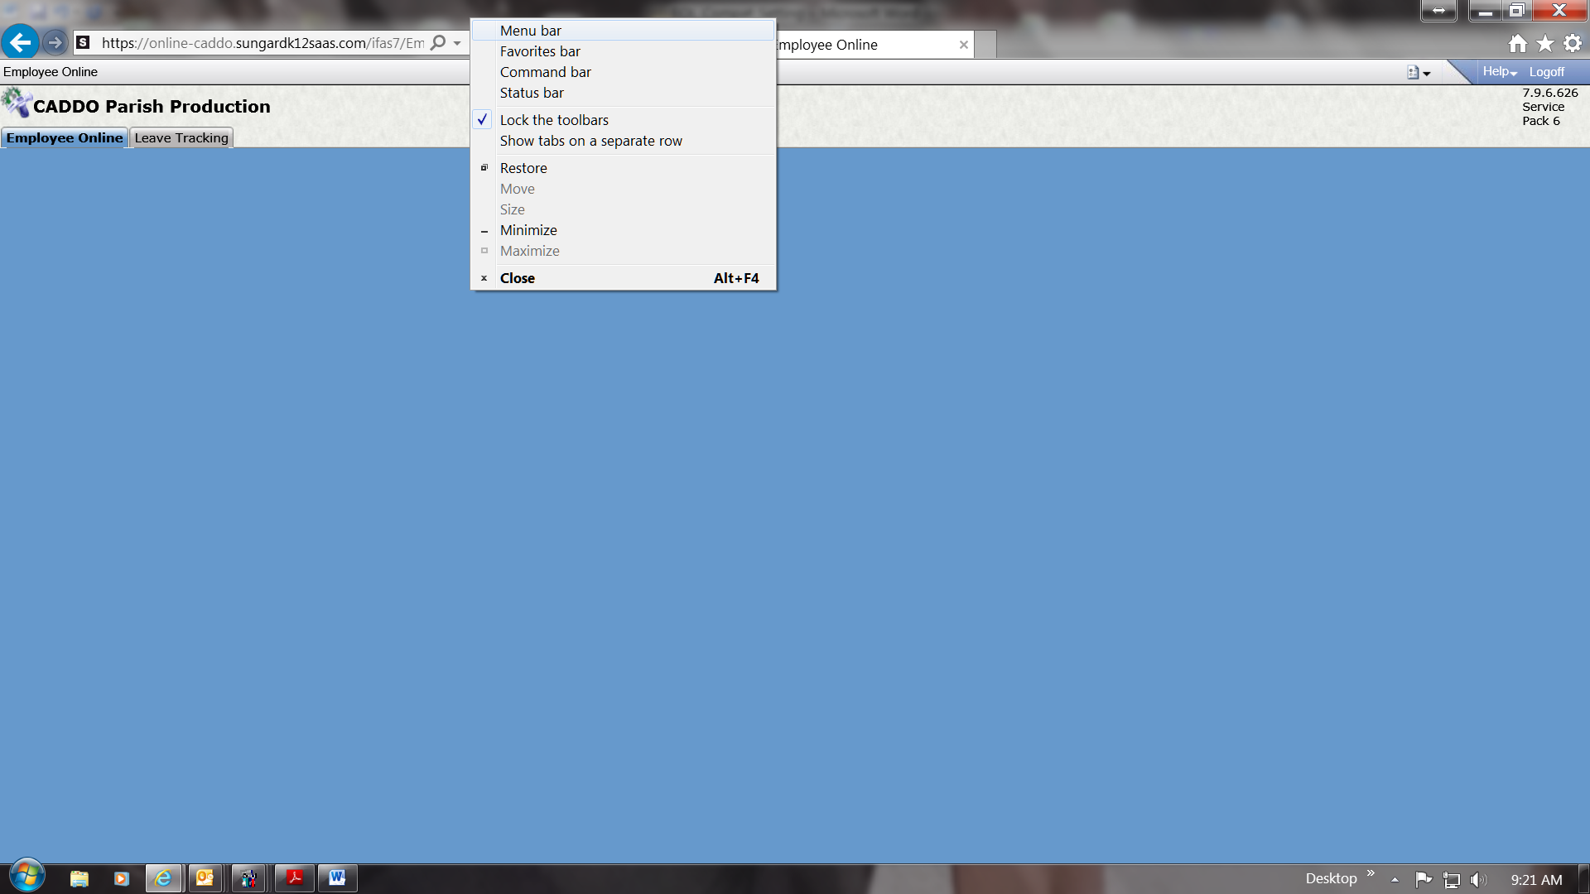

- Click to Tools.
- Scroll down to Compatibility View Settings and click on it.
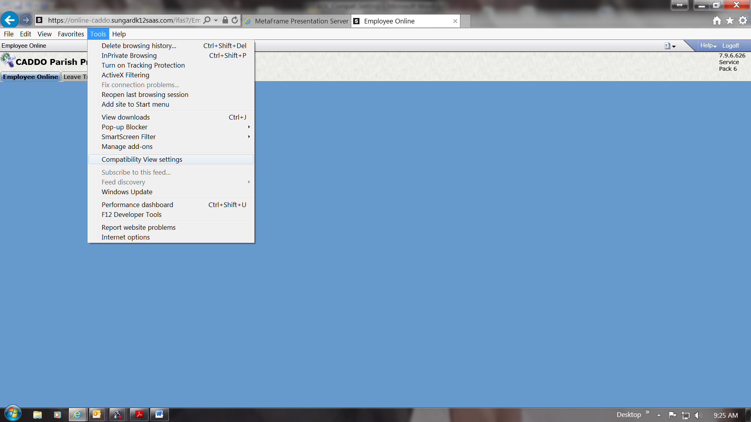

- In the box labeled “Add this website”, you should see “sungardk12saas.com”.
- Click on the ADD button and the Click the CLOSE button.
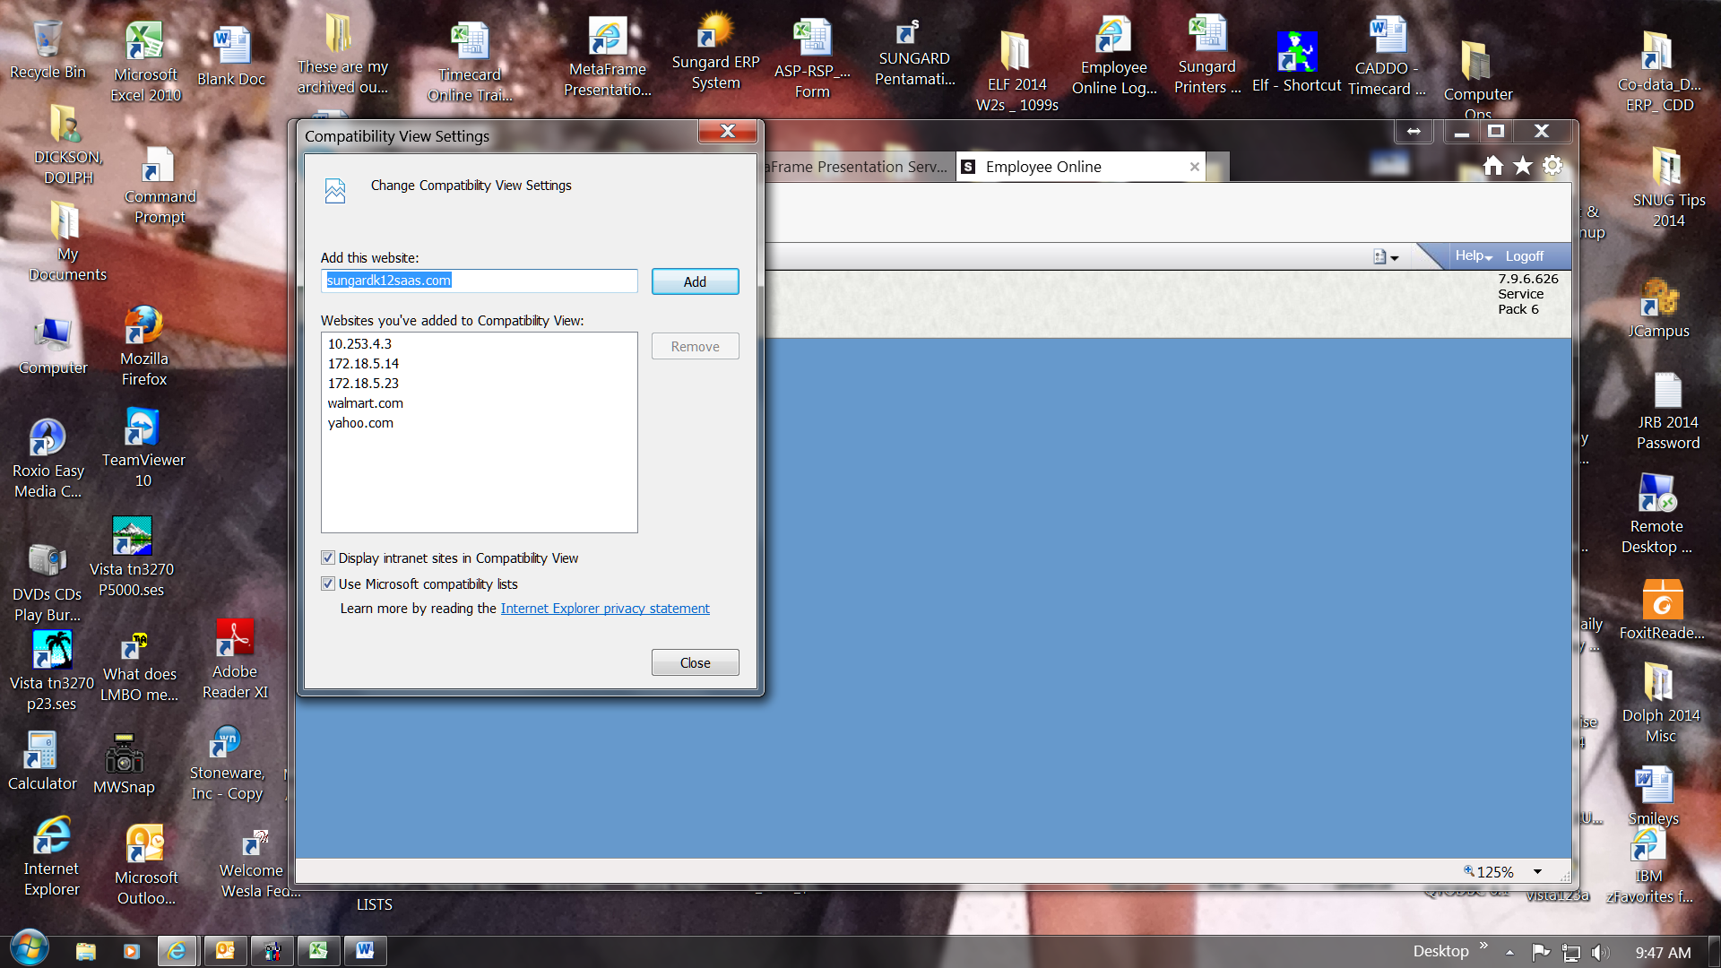
- Your menu for the Employee Online should appear now.
- Go back to the original instructions sent to you for Employee Online and proceed from there.
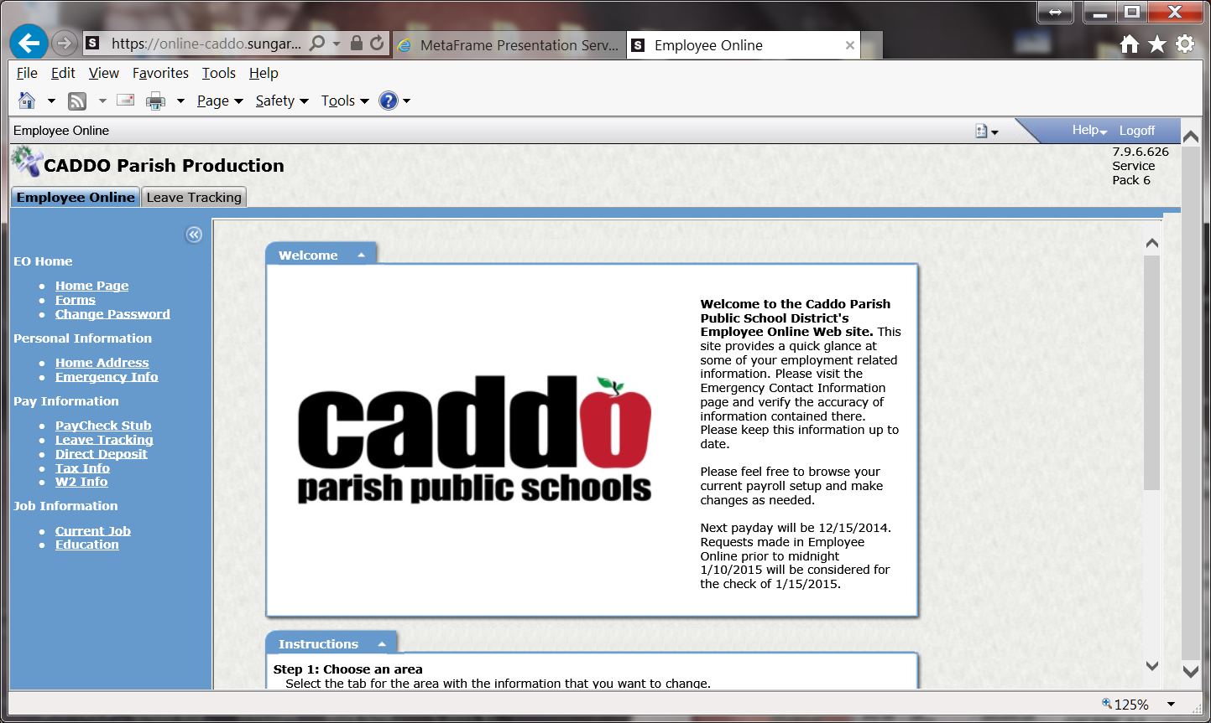
THE END……

